TUGAS KONSEP JARINGAN
TUGAS KE – 3 Classless IP



Nama
NRP
Dosen Pengajar
: Shevanka Bagus Dwiyudi Kurniawan
: 3125600044
: Dr. Ferry Astika Saputra, ST, M.Sc

PROGRAM STUDI D4 TEKNIK INFORMATIKA
POLITEKNIK ELEKTRONIKA NEGERI SURABAYA (PENS)
TAHUN 2026
- Tugas
- Gambar topologi 192.168.1.0/24 dengan 4 segmentasi jaringan
- Topologi jaringan dengan IP 132.10.0.0/16 dengan 10 segmentasi jaringan
- Topologi jaringan 17.8.0.0/16 dengan 4 segmentasi jaringan
- Topologi jaringan 8.32.0.0 dengan 6 segmentasi jaringan

- Jawaban
- 192.168.1.0/24 dengan 4 segmentasi
- Perhitungan Subnetting
- Alamat Dasar: 192.168.1.0/24 (Kelas C, default mask 255.255.255.0).
- Kebutuhan Subnet: 4 segmentasi jaringan valid.
- Perhitungan Bit Subnet ($n$):
Meminjam $n=3$ bit:
$Σ\text{ subnet valid}=2^{3}-2=6$ subnet valid (mencukupi 4 segmen)
- Prefix Baru: $/24+3=/27$.
- Subnet Mask Baru: 255.255.255.224
(biner: 11111111.11111111.11111111.11100000)
- Interval Blok Subnet (Step): $256-224=32$.
- Jumlah Host per Subnet: $2^{5}-2=30$ host usable.

- Tabel Alokasi 4 Subnet
No | Nilai Biner | Network Address | Host Pertama (Gateway) | Host Terakhir | Broadcast Address
- | 000 | 192.168.1.0/27 | 192.168.1.1 | 192.168.1.30 | 192.168.1.31
1 | 001 | 192.168.1.32/27 | 192.168.1.33 | 192.168.1.62 | 192.168.1.63
2 | 010 | 192.168.1.64/27 | 192.168.1.65 | 192.168.1.94 | 192.168.1.95
3 | 011 | 192.168.1.96/27 | 192.168.1.97 | 192.168.1.126 | 192.168.1.127
4 | 100 | 192.168.1.128/27 | 192.168.1.129 | 192.168.1.158 | 192.168.1.159
- | 101 | 192.168.1.160/27 | 192.168.1.161 | 192.168.1.190 | 192.168.1.191
- | 110 | 192.168.1.192/27 | 192.168.1.193 | 192.168.1.222 | 192.168.1.223
- | 111 | 192.168.1.224/27 | 192.168.1.225 | 192.168.1.254 | 192.168.1.255

- Skema Diagram Topologi
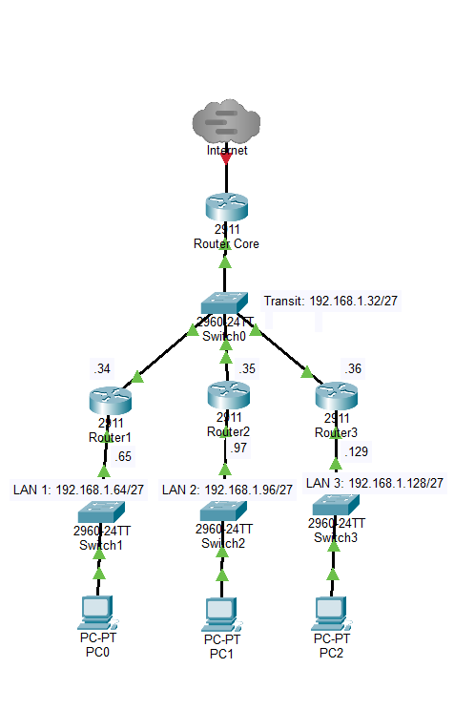

- 132.10.0.0/16 dengan 10 segmentasi
- Perhitungan Subnetting
- Alamat Dasar: 132.10.0.0/16 (Kelas B, default mask 255.255.0.0).
- Kebutuhan Subnet: 10 segmentasi jaringan.
- Jumlah Bit yang Dipinjam ($n$):
$2^{n}≥10⟹n=4 \left(2^{4}=16\text{ subnet}\right)$ Prefix Baru: $/16+4=/20$.
- Subnet Mask Baru: 255.255.240.0 (biner oktet ke-3: 11110000).
- Interval Blok Subnet (Step): $256-240=16$ pada oktet ke-3.
- Jumlah Host per Subnet: $2^{12}-2=4.094$ host usable.

- Tabel Alokasi 6 Subnet
No | Biner | Network Address | Host Pertama (Gateway) | Host Terakhir | Broadcast  Address
- | 0000 | 132.10.0.0/20 | 132.10.0.1 | 132.10.15.254 | 132.10.15.255
1 | 0001 | 132.10.16.0/20 | 132.10.16.1 | 132.10.31.254 | 132.10.31.255
2 | 0010 | 132.10.32.0/20 | 132.10.32.1 | 132.10.47.254 | 132.10.47.255
3 | 0011 | 132.10.48.0/20 | 132.10.48.1 | 132.10.63.254 | 132.10.63.255
4 | 0100 | 132.10.64.0/20 | 132.10.64.1 | 132.10.79.254 | 132.10.79.255
5 | 0101 | 132.10.80.0/20 | 132.10.80.1 | 132.10.95.254 | 132.10.95.255
6 | 0110 | 132.10.96.0/20 | 132.10.96.1 | 132.10.111.254 | 132.10.111.255
7 | 0111 | 132.10.112.0/20 | 132.10.112.1 | 132.10.127.254 | 132.10.127.255
8 | 1000 | 132.10.128.0/20 | 132.10.128.1 | 132.10.143.254 | 132.10.143.255
9 | 1001 | 132.10.144.0/20 | 132.10.144.1 | 132.10.159.254 | 132.10.159.255
10 | 1010 | 132.10.160.0/20 | 132.10.160.1 | 132.10.175.254 | 132.10.175.255
- | ... | Cadangan (1011–1110) | ... | ... | ...
- | 1111 | 132.10.240.0/20 | 132.10.240.1 | 132.10.255.254 | 132.10.255.255
- Skema Diagram Topologi
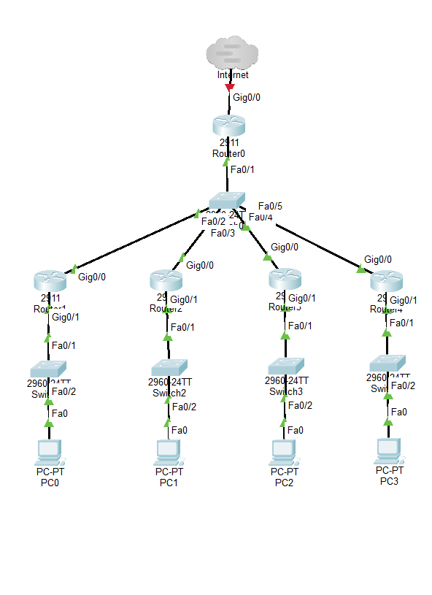

- 17.8.0.0/16 dengan 4 segmentasi
- Perhitungan Subnetting
- Alamat Dasar: 17.8.0.0/16 (Kelas B, default mask /16).
- Kebutuhan Subnet: 4 segmentasi valid.
- Jumlah Bit Subnet ($n$):
Maka meminjam $n=3$ bit: $2^{3}-2=6$ subnet valid (mencukupi 4 segmen).
- Prefix Baru: $/16+3=/19$.
- Subnet Mask Baru: 255.255.224.0 (biner oktet ke-3: 11100000).
- Interval Blok Subnet (Step): $256-224=32$ pada oktet ke-3.
- Jumlah Host per Subnet: $2^{13}-2=8.190$ host usable.

- Tabel Alokasi 6 Subnet
No | Biner | Network Address | Host Pertama (Gateway) | Host Terakhir | Broadcast Address
- | 000 | 17.8.0.0/19 | 17.8.0.1 | 17.8.31.254 | 17.8.31.255
1 | 001 | 17.8.32.0/19 | 17.8.32.1 | 17.8.63.254 | 17.8.63.255
2 | 010 | 17.8.64.0/19 | 17.8.64.1 | 17.8.95.254 | 17.8.95.255
3 | 011 | 17.8.96.0/19 | 17.8.96.1 | 17.8.127.254 | 17.8.127.255
4 | 100 | 17.8.128.0/19 | 17.8.128.1 | 17.8.159.254 | 17.8.159.255
- | ... | Cadangan (101–110) | ... | ... | ...
- | 111 | 17.8.224.0/19 | 17.8.224.1 | 17.8.255.254 | 17.8.255.255

- Skema Diagram Topologi
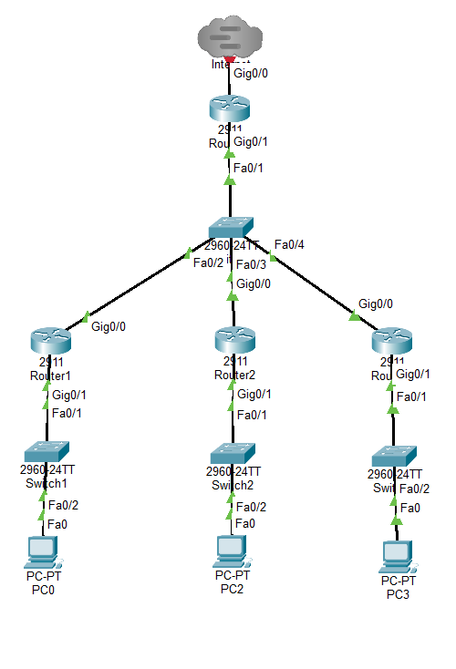

- 8.32.0.0 dengan 6 segmentasi
- Perhitungan Subnetting
- Alamat Dasar: 8.32.0.0/12
- Kebutuhan Subnet: 6 segmentasi valid.
- Jumlah Bit Subnet ($n$):
$2^{n}-2≥6⟹2^{n}≥8⟹n=3\text{ bit}$
- Prefix Baru: $/12+3=/15$.
- Subnet Mask Baru:
  - Oktet 1: 11111111 = 255
  - Oktet 2: 4 bit asal (1111) + 3 bit subnet (111) + 1 bit host (0) = 11111110 = 254
  - Subnet Mask: 255.254.0.0.
- Interval Blok Subnet (Step): $256-254=2$ pada oktet ke-2.
- Jumlah Host per Subnet: $2^{17}-2=131.070$ host usable.

- Tabel Alokasi 6 Subnet
No | Biner | Network Address | Host Pertama  (Gateway) | Host Terakhir | Broadcast Address
- | 000 | 8.32.0.0/15 | 8.32.0.1 | 8.33.255.254 | 8.33.255.255
1 | 001 | 8.34.0.0/15 | 8.34.0.1 | 8.35.255.254 | 8.35.255.255
2 | 010 | 8.36.0.0/15 | 8.36.0.1 | 8.37.255.254 | 8.37.255.255
3 | 011 | 8.38.0.0/15 | 8.38.0.1 | 8.39.255.254 | 8.39.255.255
4 | 100 | 8.40.0.0/15 | 8.40.0.1 | 8.41.255.254 | 8.41.255.255
5 | 101 | 8.42.0.0/15 | 8.42.0.1 | 8.43.255.254 | 8.43.255.255
6 | 110 | 8.44.0.0/15 | 8.44.0.1 | 8.45.255.254 | 8.45.255.255
- | 111 | 8.46.0.0/15 | 8.46.0.1 | 8.47.255.254 | 8.47.255.255

- Skema Diagram Topologi
